Lootin Looters 04/11/2019

Designer: Raffaele Gambuto

Overview

Level Location and Environment-

Middle of nowhere

Procedurally generated rooms

Medieval, Modern and Sci-fi rooms

Level Assets-

Props--

Breastplate

Shield

Arming sword

Longsword

Modern bed

Futton

Medieval bed

Sci-fi bed

Sci-fi lights

Sci-fi chair

Traps

Barrel

Log and axe

Bookshelf

Cross

Mirror

Sci-fi mirror

Pipe

Fan

Sci-fi tables

Medieval table

Torture table

Modern table

Torch

Modern lights

Chandelier

Modern chairs

Medieval chairs

Light switch

Painting

Plasma tv

Wall mounted tv

Carpets

Garbages

Vase

Chest

Laundry basket

Wall computer

Dresser

Power-ups / Collectibles--

Loot

Slow trap

Stop trap

Level Difficulty-

Procedurally generated levels aren’t really reliable difficult or not.

Most of the time not difficult though, every area is different and you just got to get away from the guard.

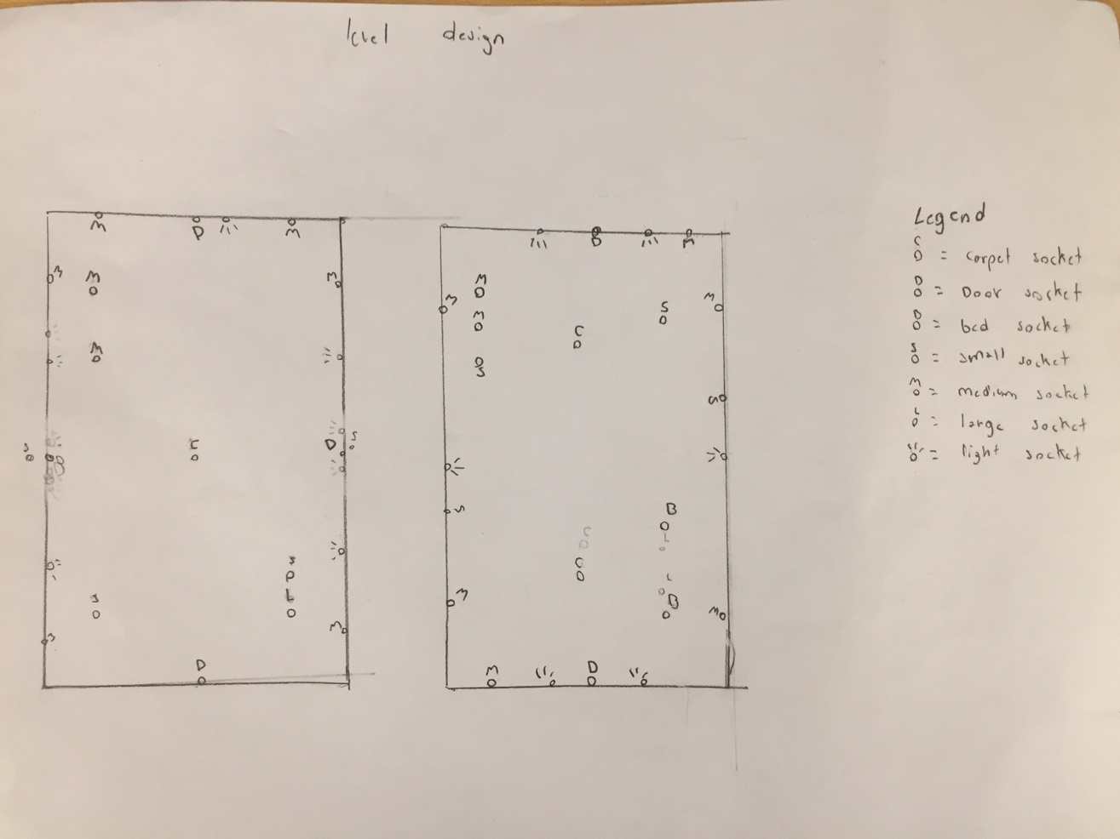

Map Layout

See above

Map Description

It is all sockets and different types to procedurally generate assets. There are also different types like the medieval, modern and sci-fi, but they are all with the same layout, simply different type specifiers.

Pacing Chart

N/A, it be randomized.